**Title**: **Development and Validation of a Prediction Model for Identifying Critical Patients**

**Problem Statement:** The characteristics of critically ill patients upon admission remain poorly understood. We aimed to bridge this gap by developing and validating a prediction model for identifying patients at risk of critical conditions during their hospital stay.

**Data**: The dataset comprises various factors related to patients during hospitalization, encompassing medical history (such as Aids, cirrhosis, hypertension, diabetes mellitus etc.), vital signs, and other pertinent parameters. The primary objective is to leverage this comprehensive dataset to predict whether a patient is likely to become critically ill during their in-hospital stay.

**Findings**: Through rigorous analysis and modeling, we successfully developed a predictive model for identifying critical patients. The model utilizes the diverse factors present in the dataset to generate accurate predictions. The validation process demonstrated the robustness and generalizability of the model across different patient populations.

**Implications**: The developed prediction model has significant implications for clinical practice, enabling healthcare providers to proactively identify patients at risk of critical conditions early on. This advancement can lead to timely interventions, potentially improving patient outcomes and optimizing resource allocation within healthcare settings. Future research may further refine the model and explore additional factors contributing to critical conditions in hospitalized patients.

**Problem Solving Methodology Overview:**

* **Understanding the Problem:**
  + Developing and validating a prediction model for all-cause in-hospital mortality and identifying critical patients.
  + Create a predictive model using a dataset of various patient-related factors such as BMI, elective surgery,ICUadmit source, ICU type, Apache scores, heart rate, respiratory rate, glucose level, diastolic bp etc.
* **Exploratory Data Analysis (EDA):**
* Examine the dataset: Understand the structure, types of variables, and their distributions.

**SHAPE OF THE DATA**

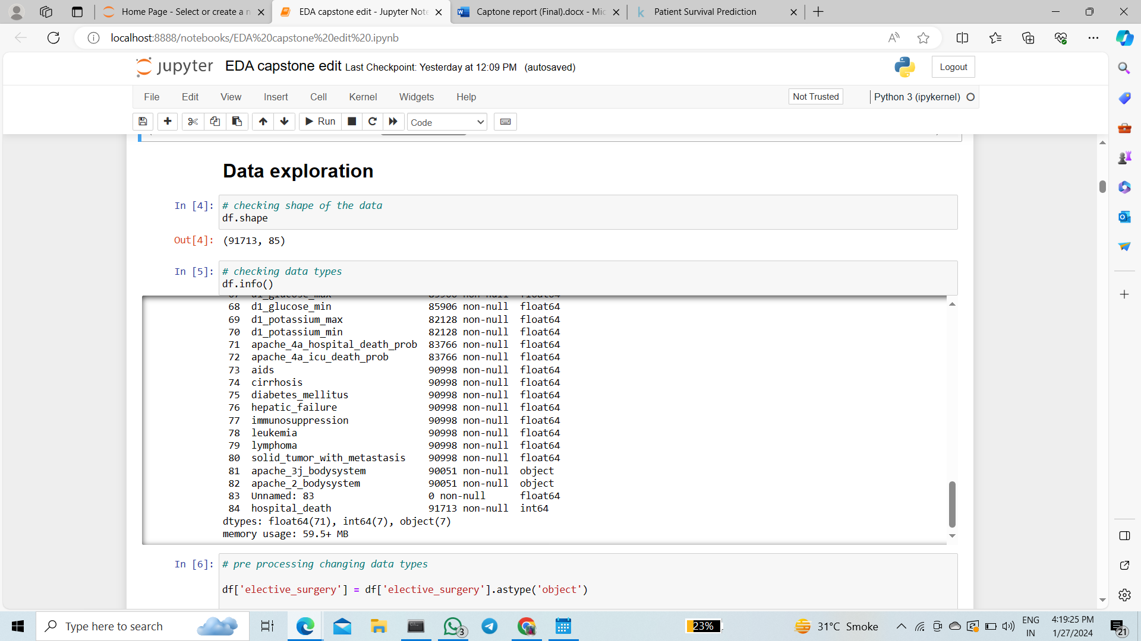

**DATA TYPE**



**DISTRIBUTION OF THE DATA**

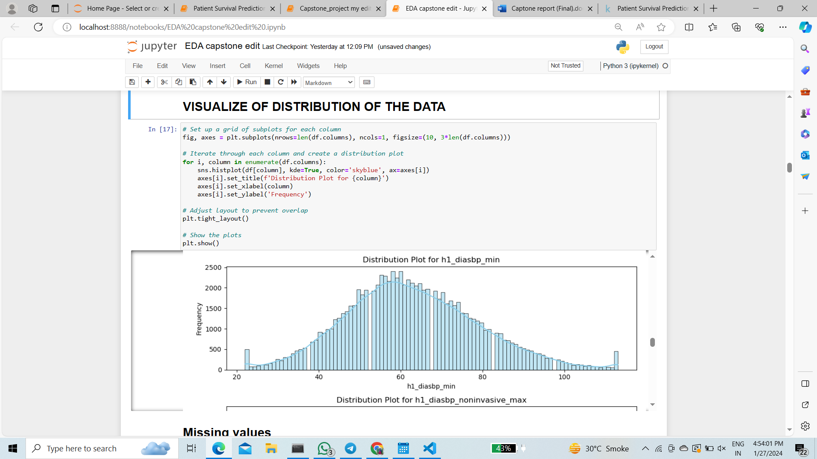

We have dropped redundant columns -'encounter_id','patient_id','Unnamed: 83','hospital_id','icu_id'.

1. Unnamed columns have all the nan values
2. After analysis drop all id columns as they have unique values or high variations.

**Identify missing values: Handle missing data appropriately.**

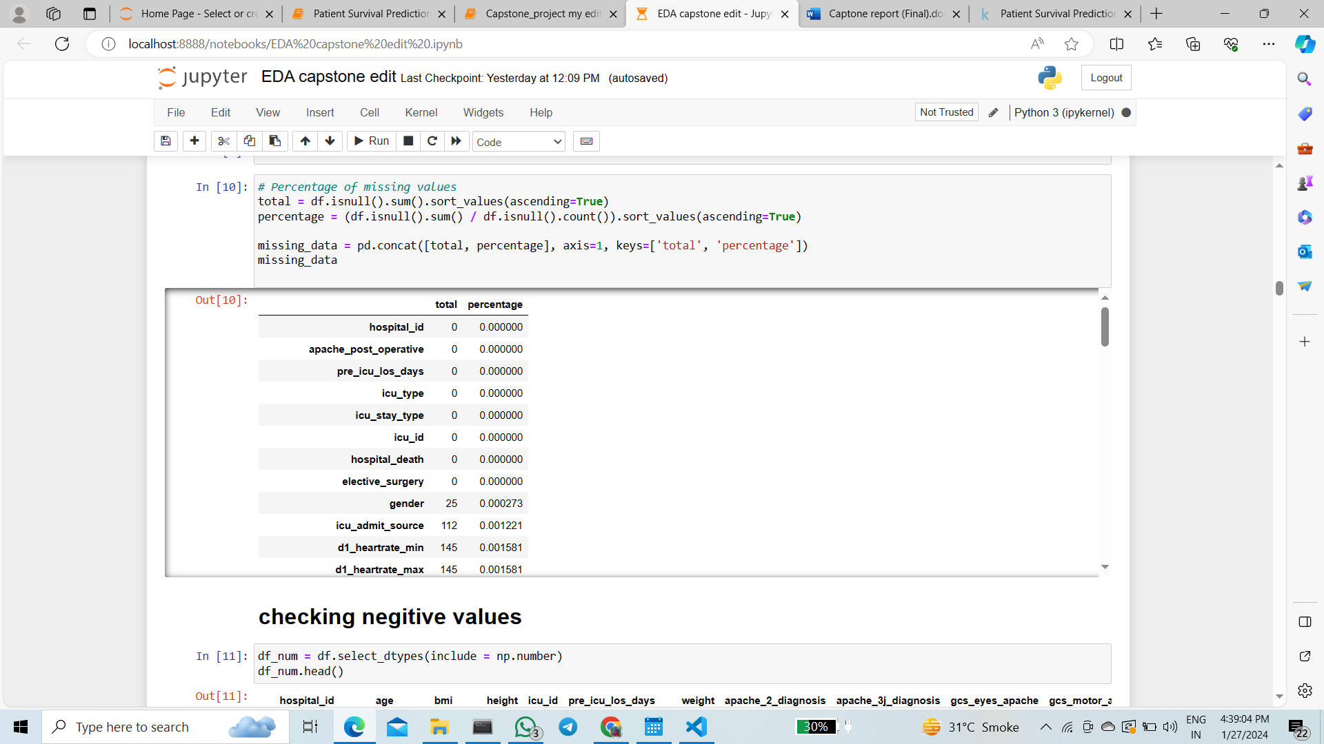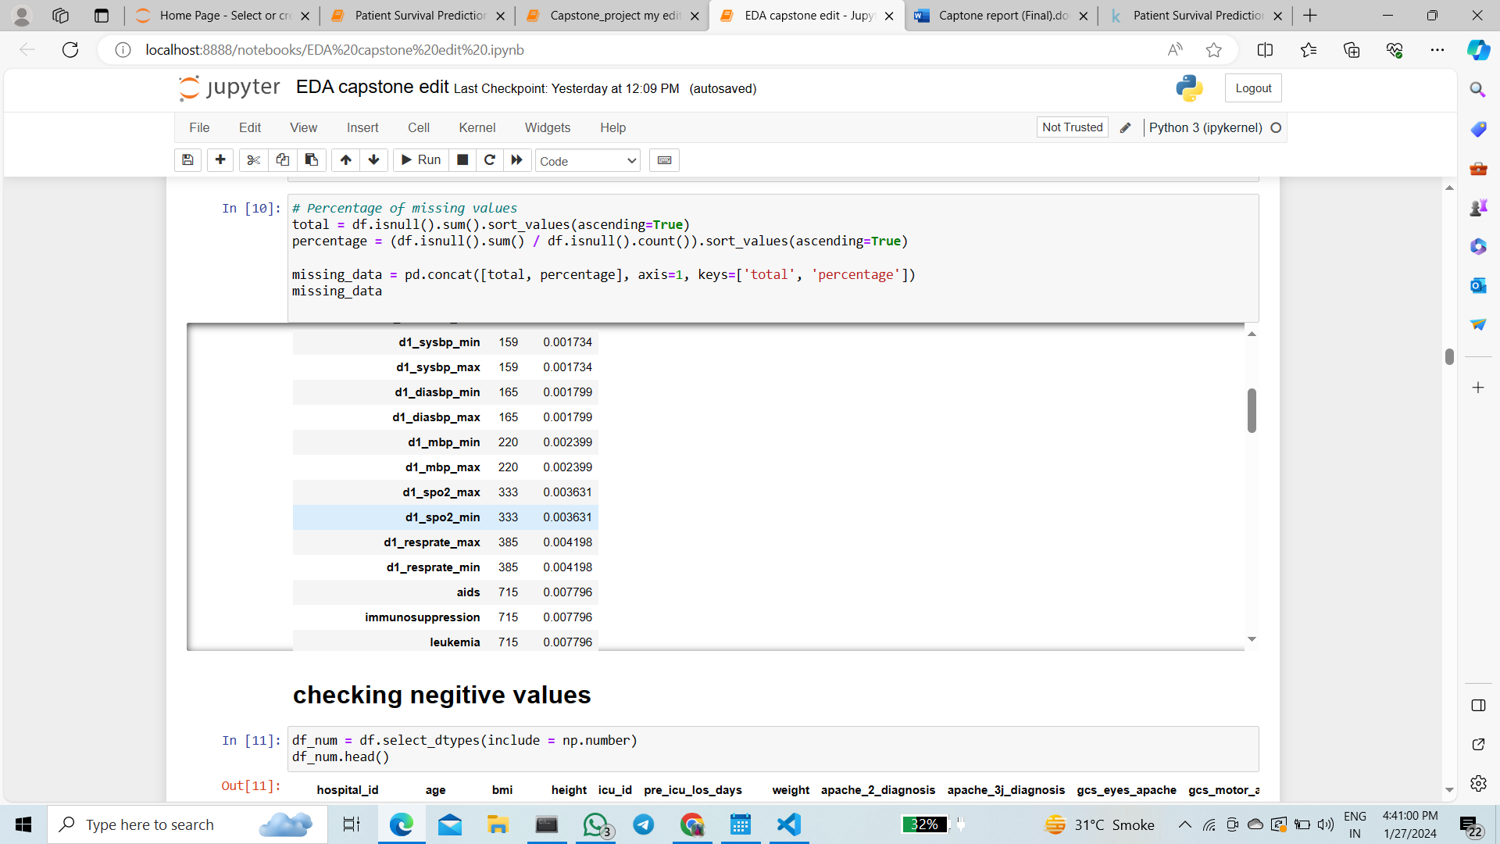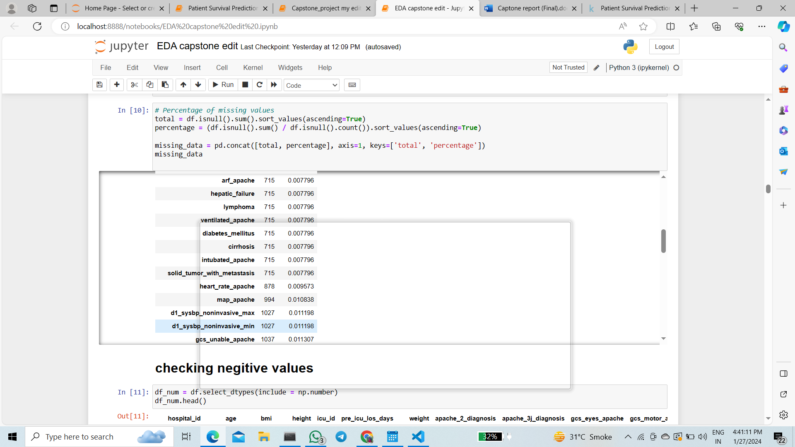

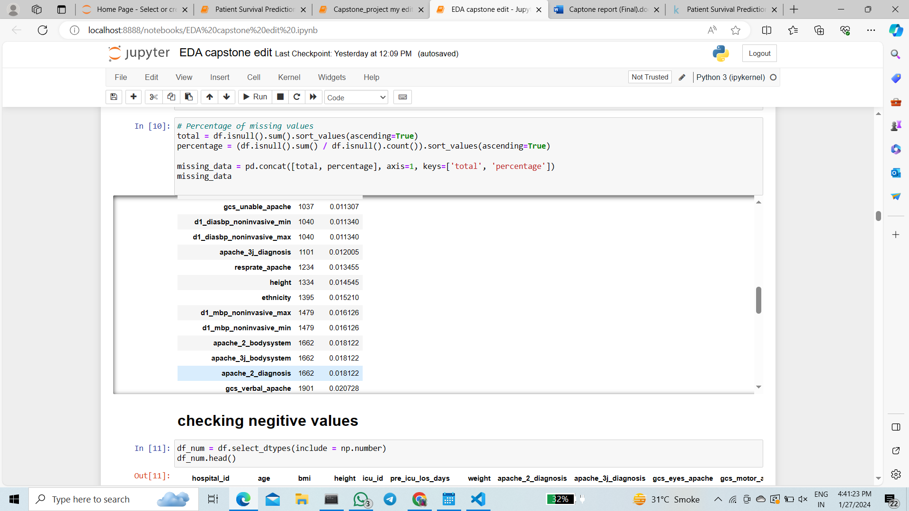

**NEGITIVE VALUES TREATMENT**

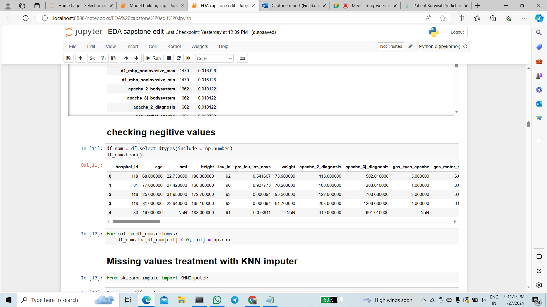

**Treating missing values**

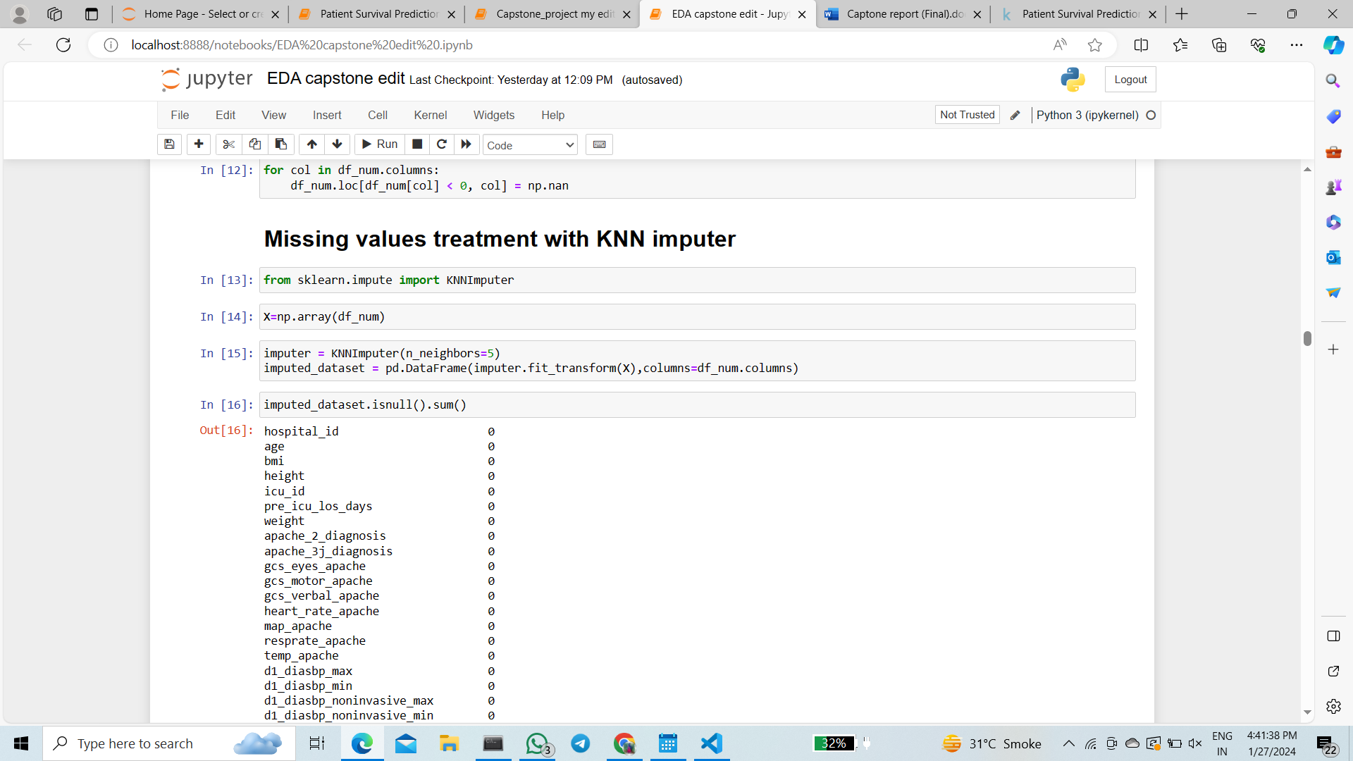

**Treating missing values of categorical variable**

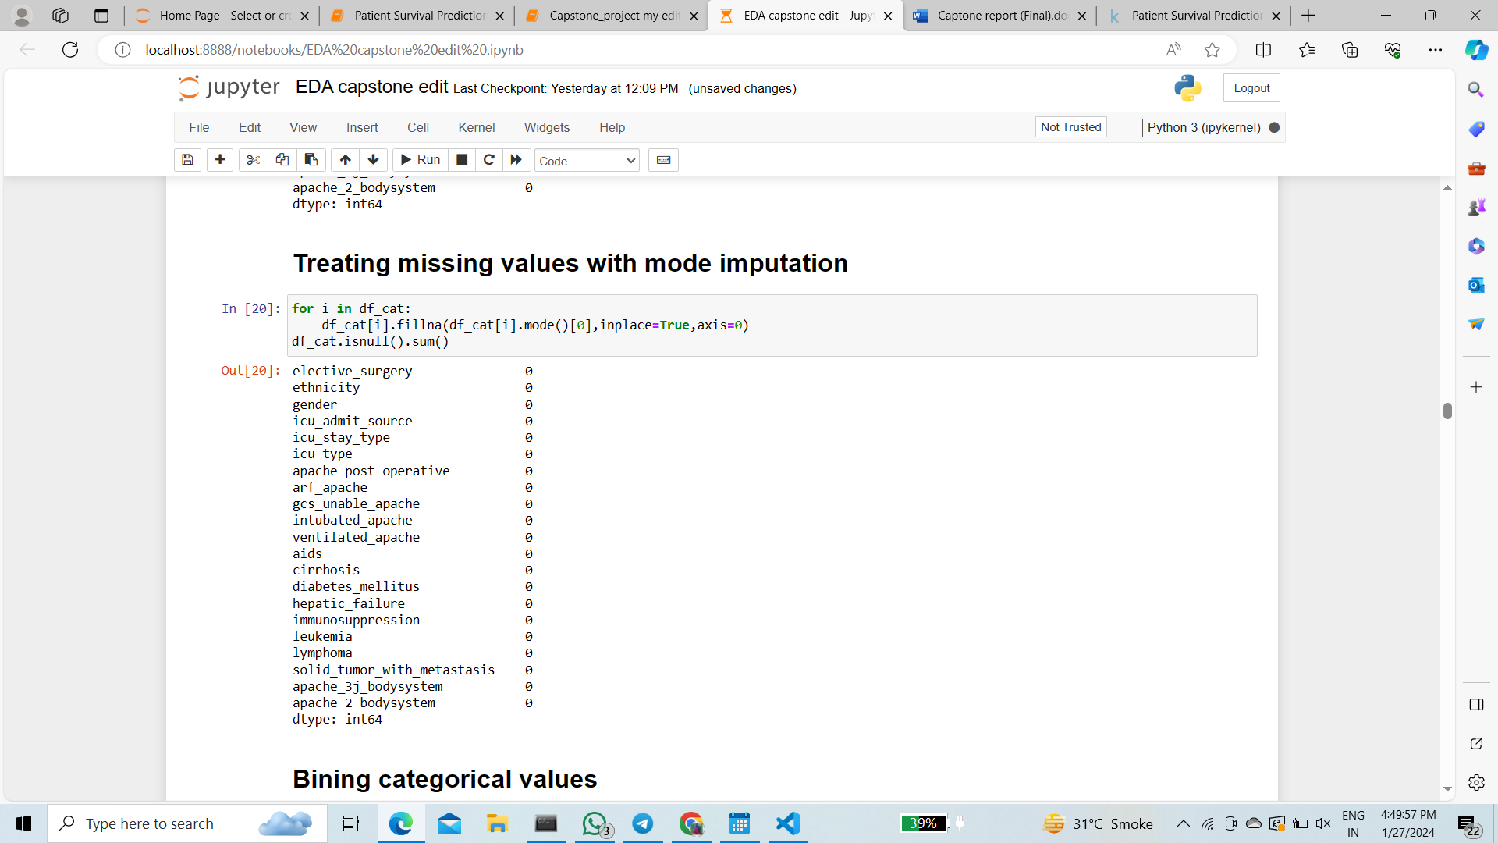

1. There are high number of missing values in 50% of the numeric and categorical columns – imputed using KNN imputer and mode imputation respectively.
2. Pre_icu_los_days, apache_3j_prob, apache_2j_prob have negative values which is converted into nan and then imputed with KNN imputer

**BINNING OF CATEGORICAL COLUMNS**

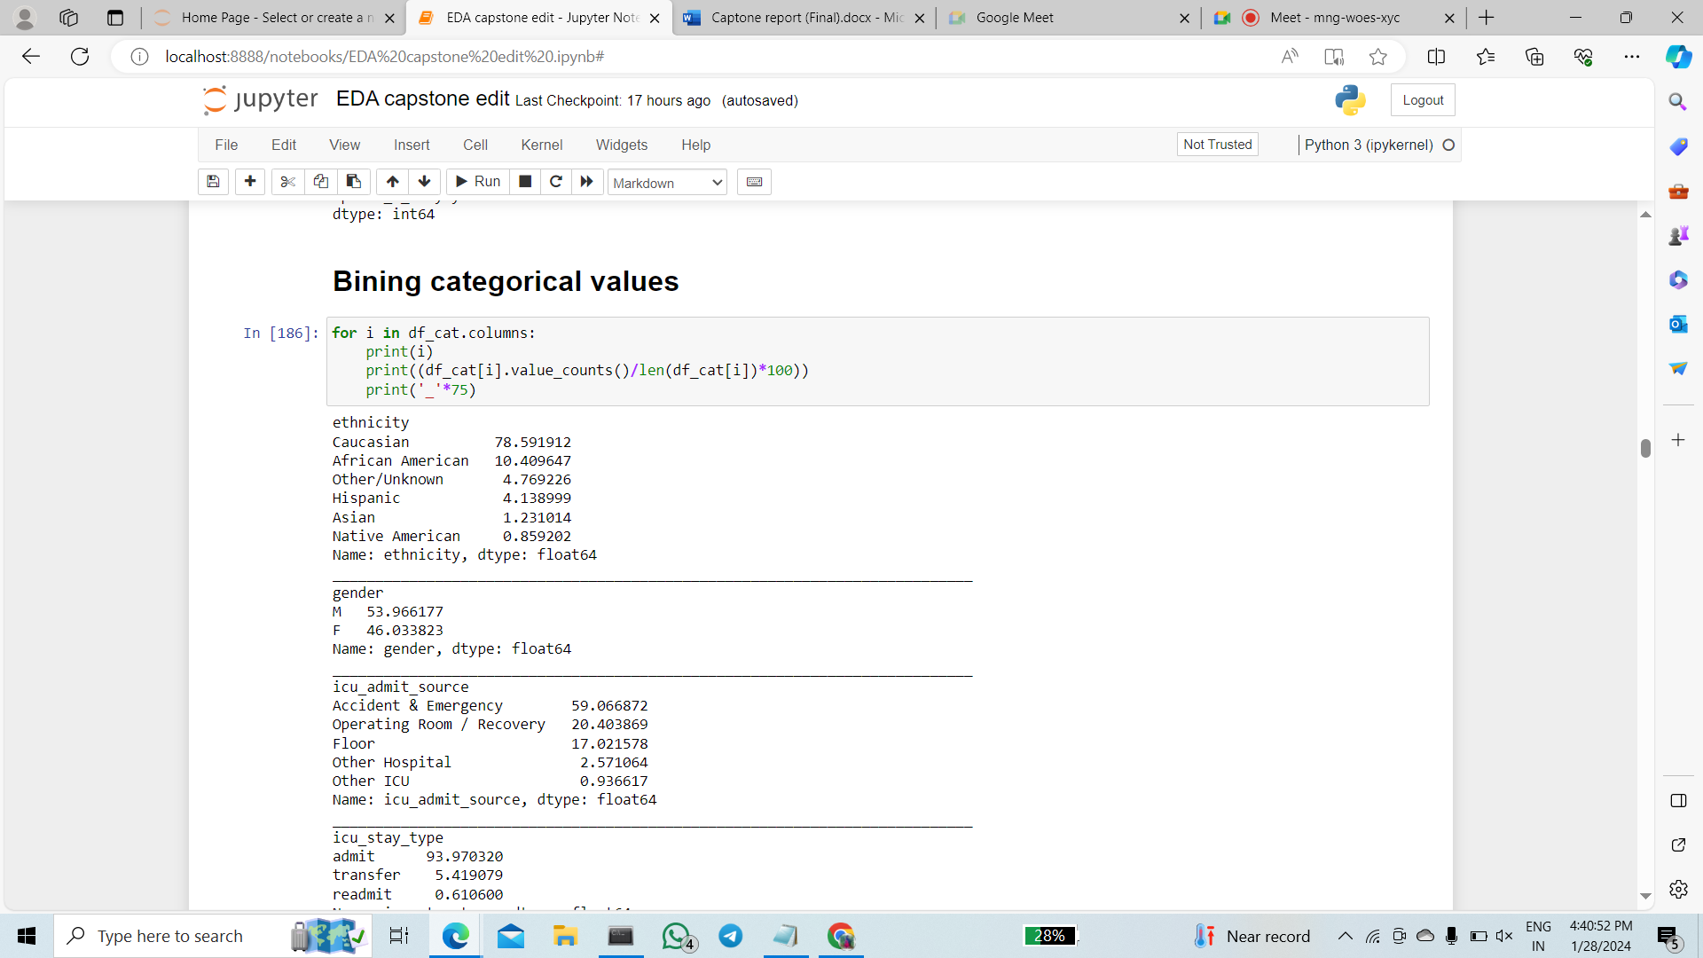

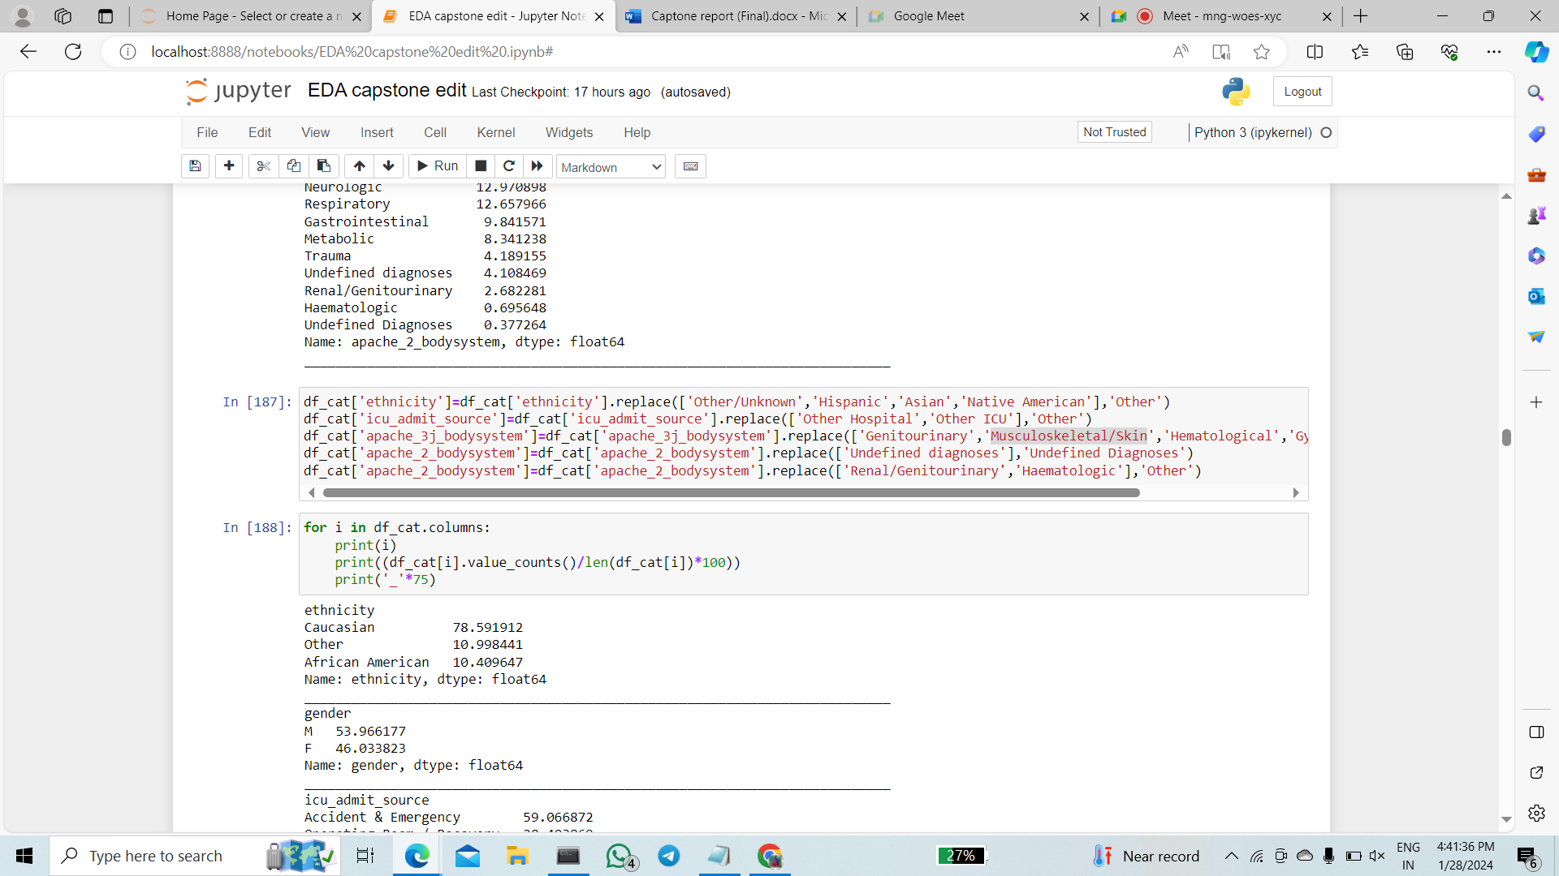

1. We perform binning of categorical columns and dummy encode categorical columns

**DUMMY ENCODING CATEGORICAL COLUMNS**

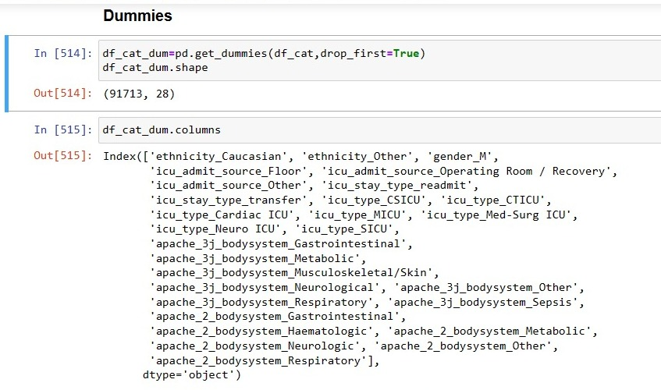

* **Visualize relationships: Explore correlations and patterns between variables to gain insights**

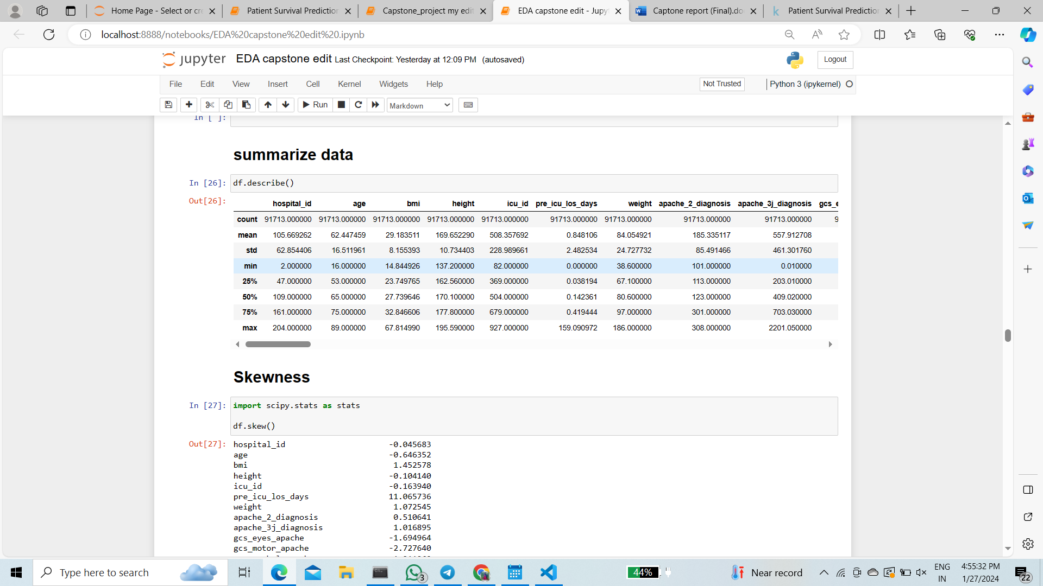

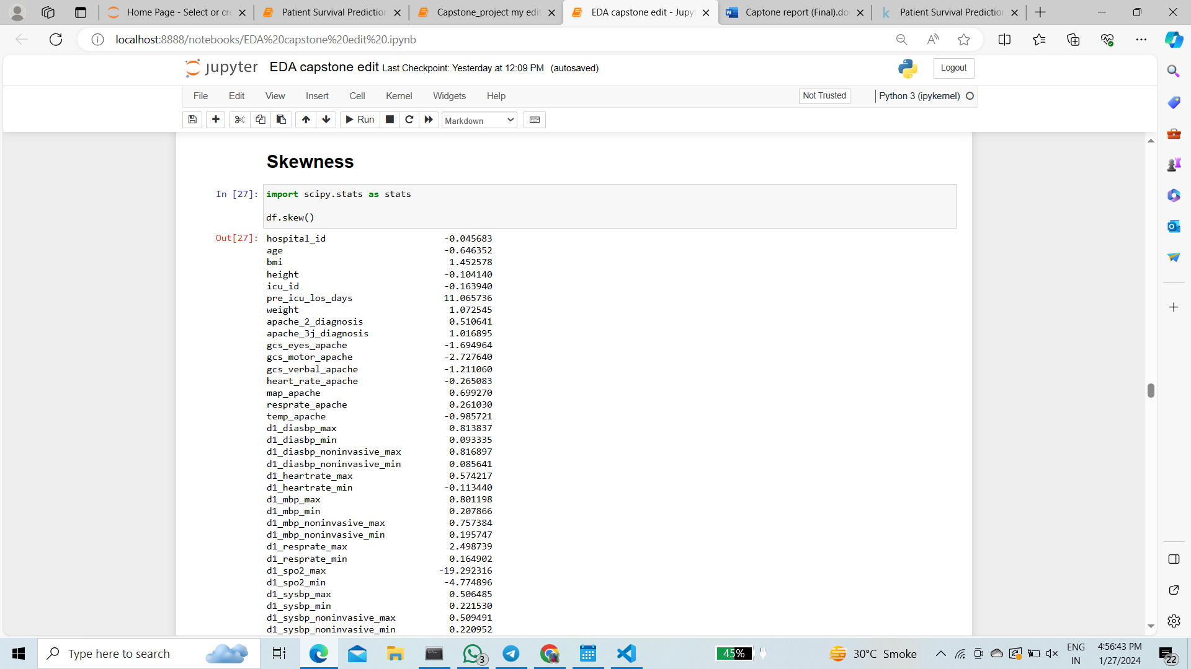

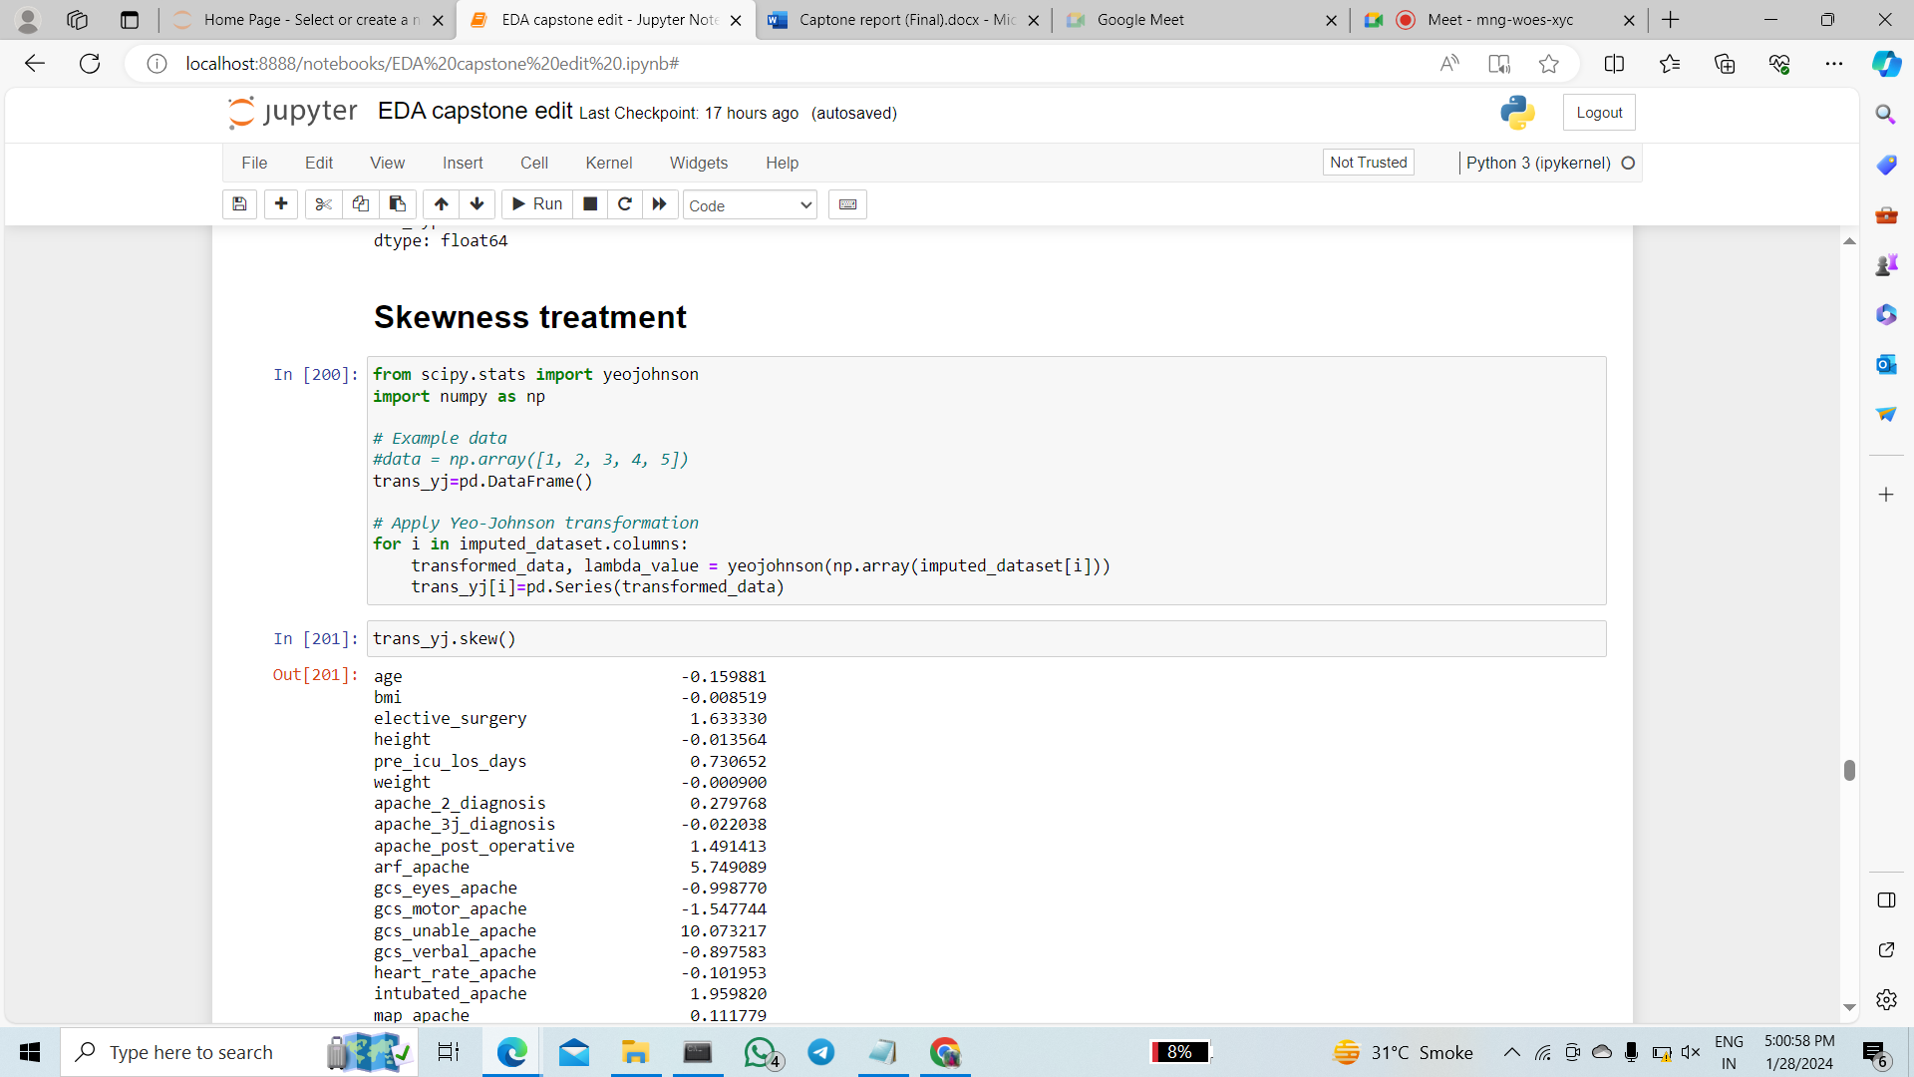

The data was highly skewed for some of the columns which is treated using yeo johnson method to get in range between –1 to 1

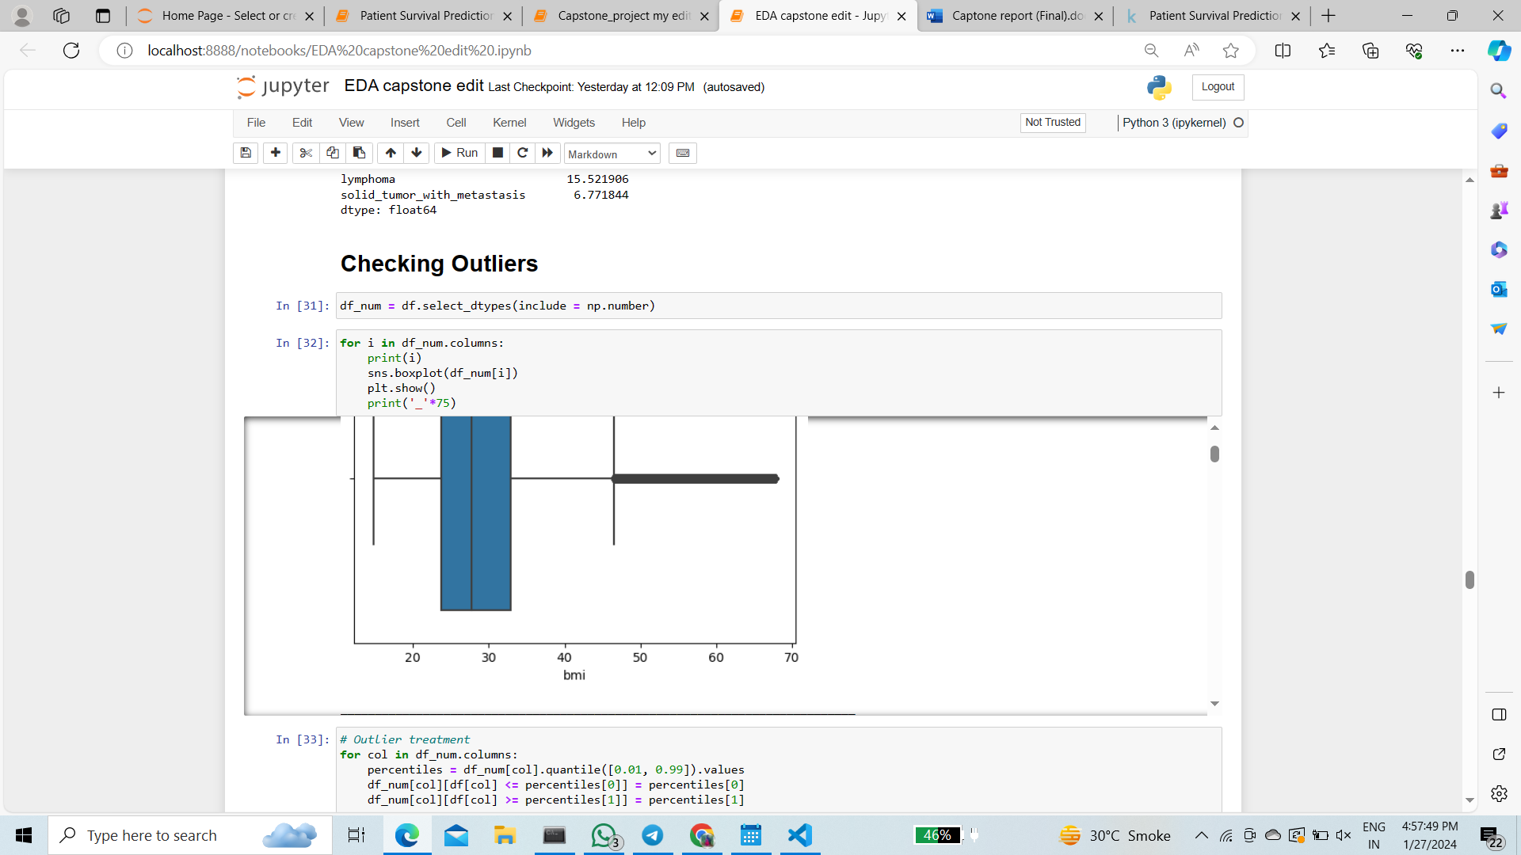

**CHECKING OUTLIERS OF CATEGORICAL VALUES**

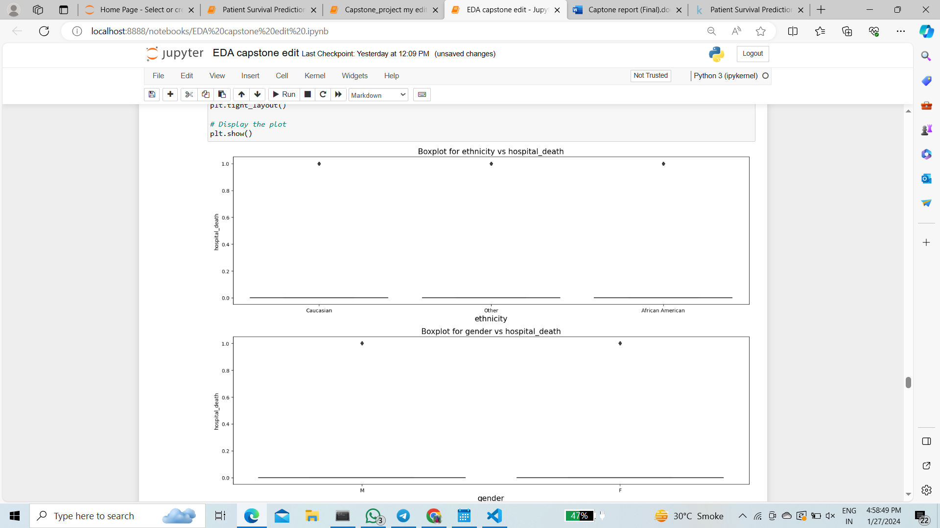

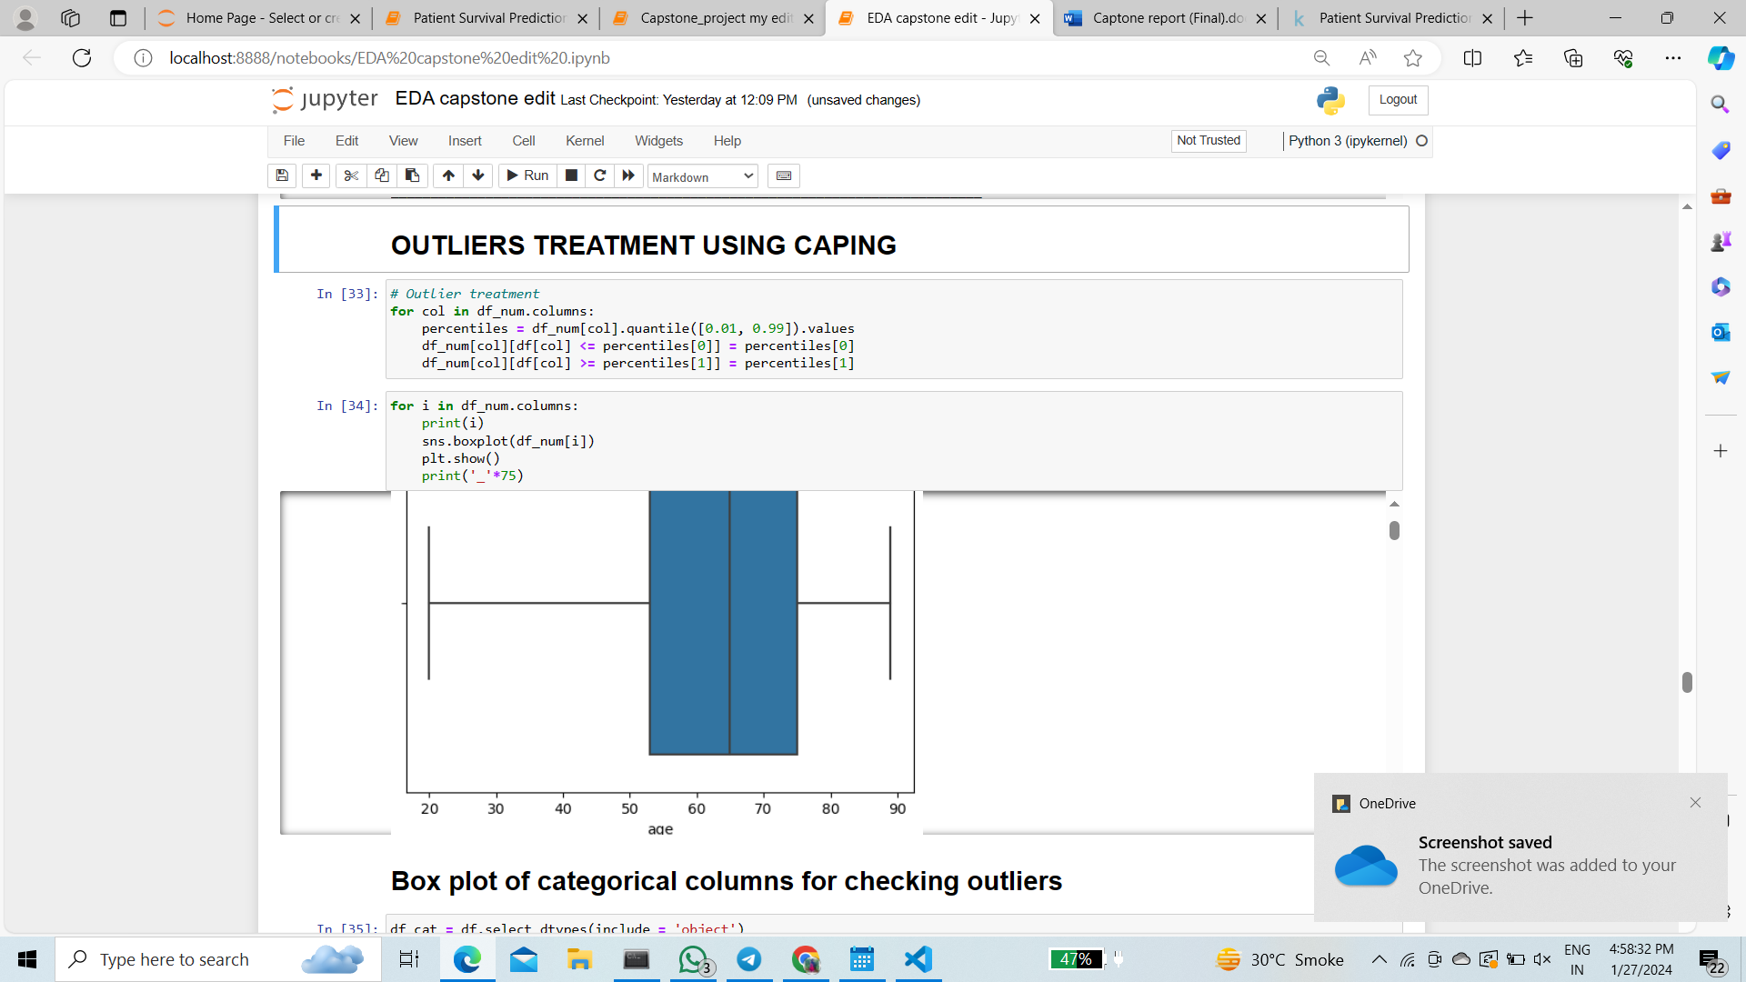

1. For outliers we used capping of percentile 0.01 and 0.99.

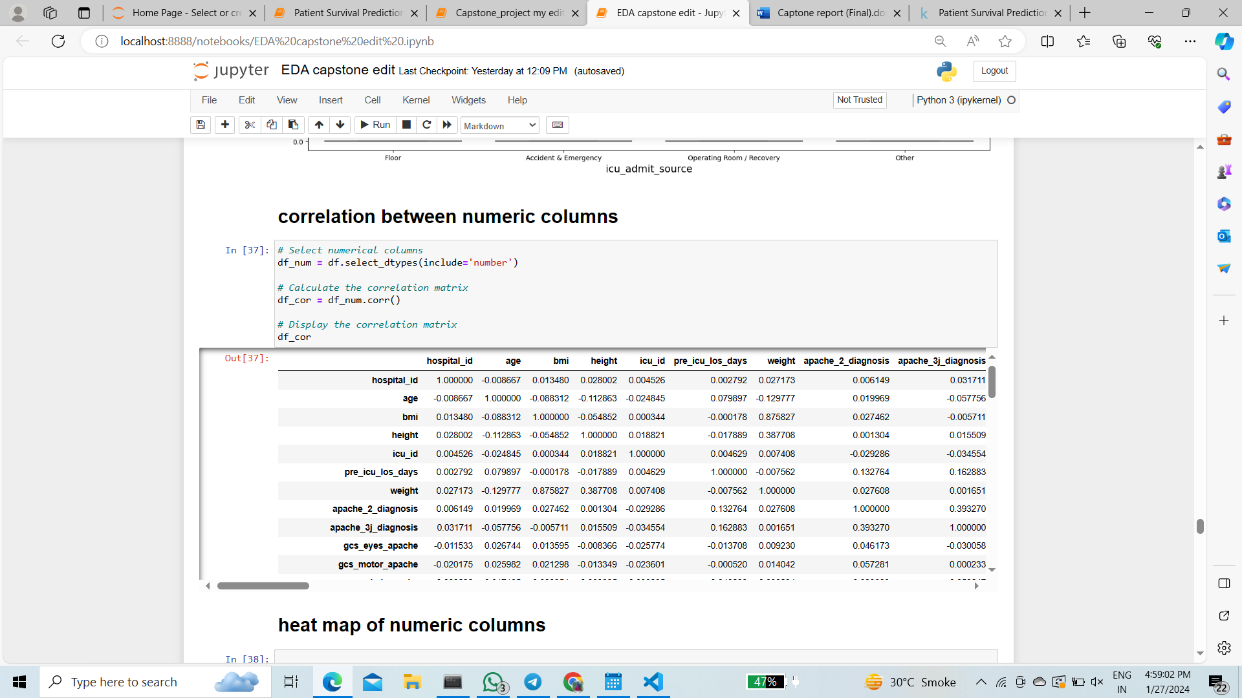

**ETHINICITY VS BMI**

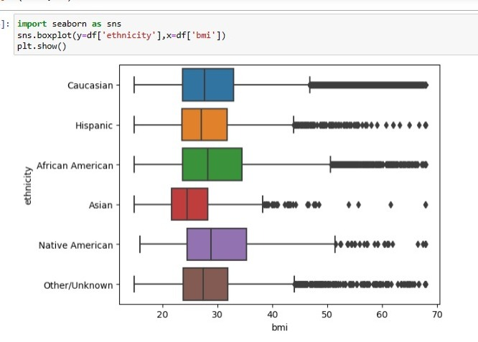

**HEAT MAP**

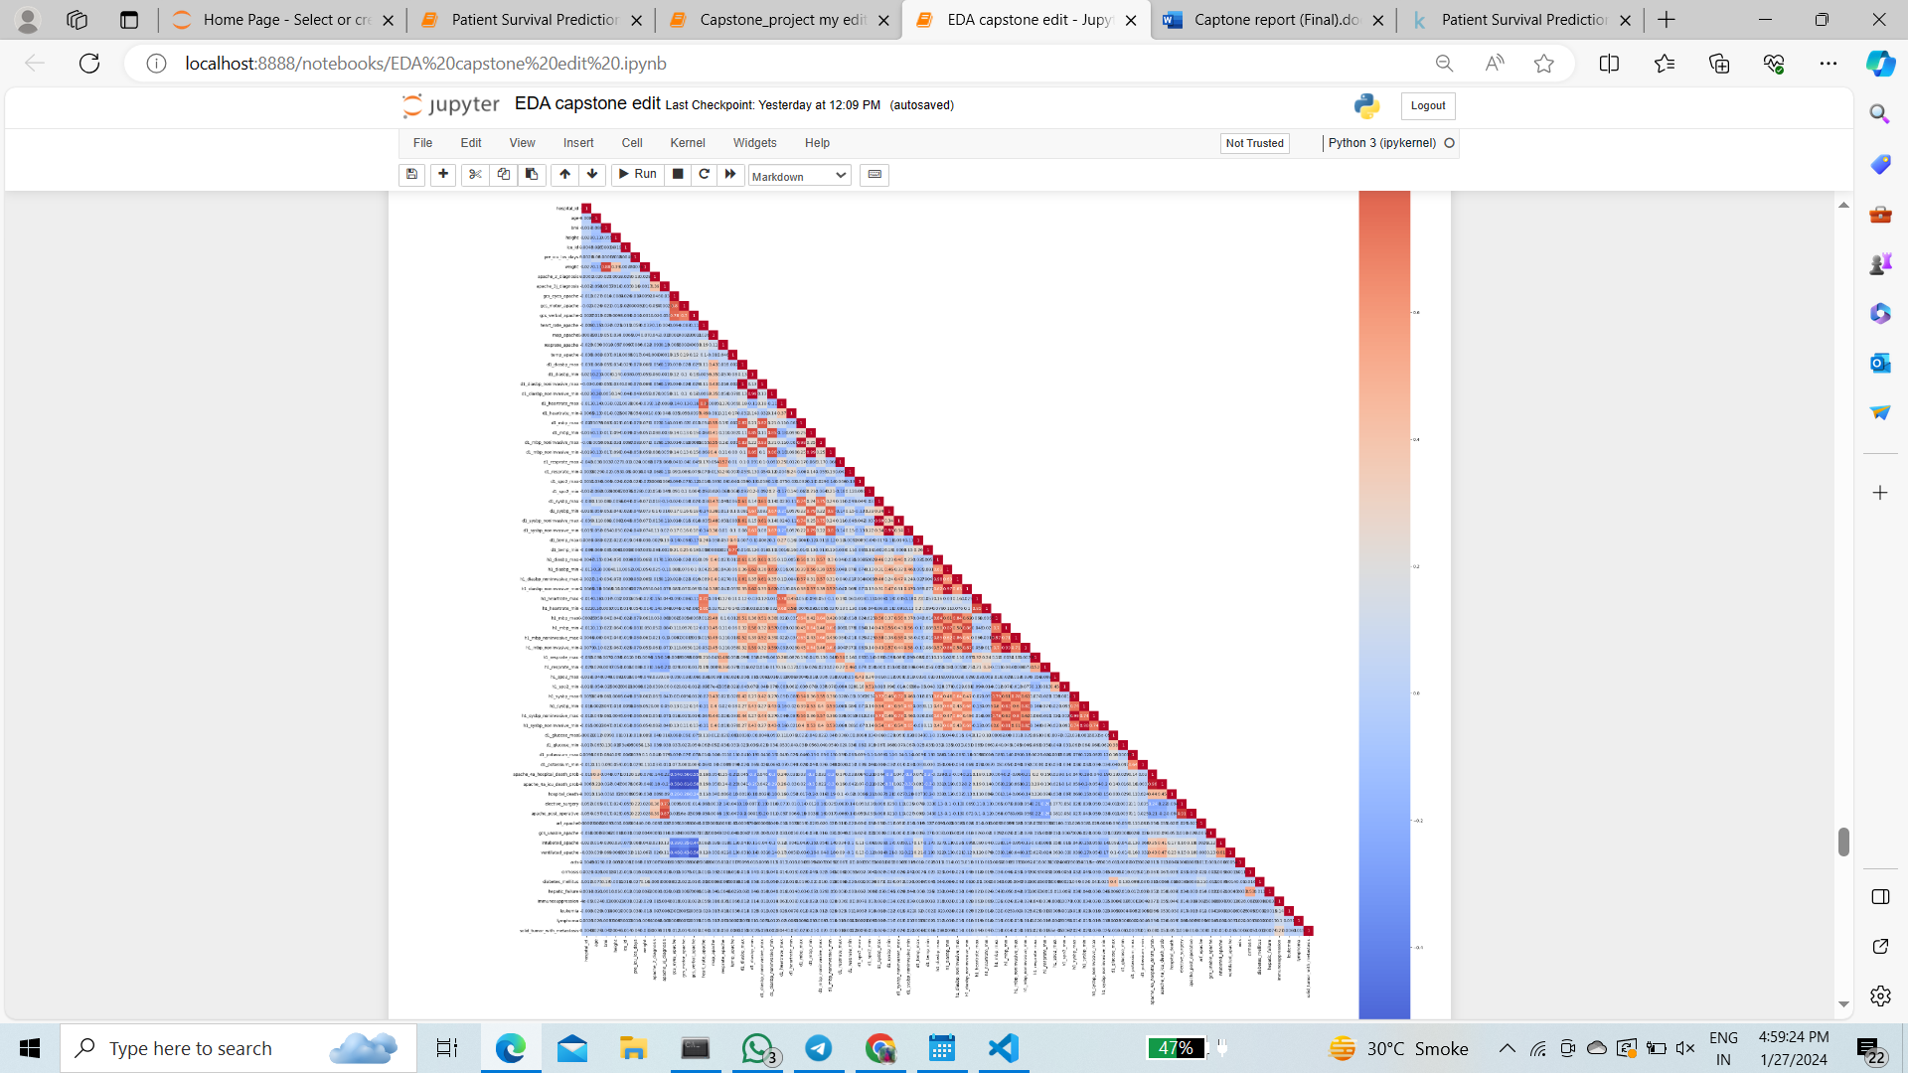

**STATS TEST**

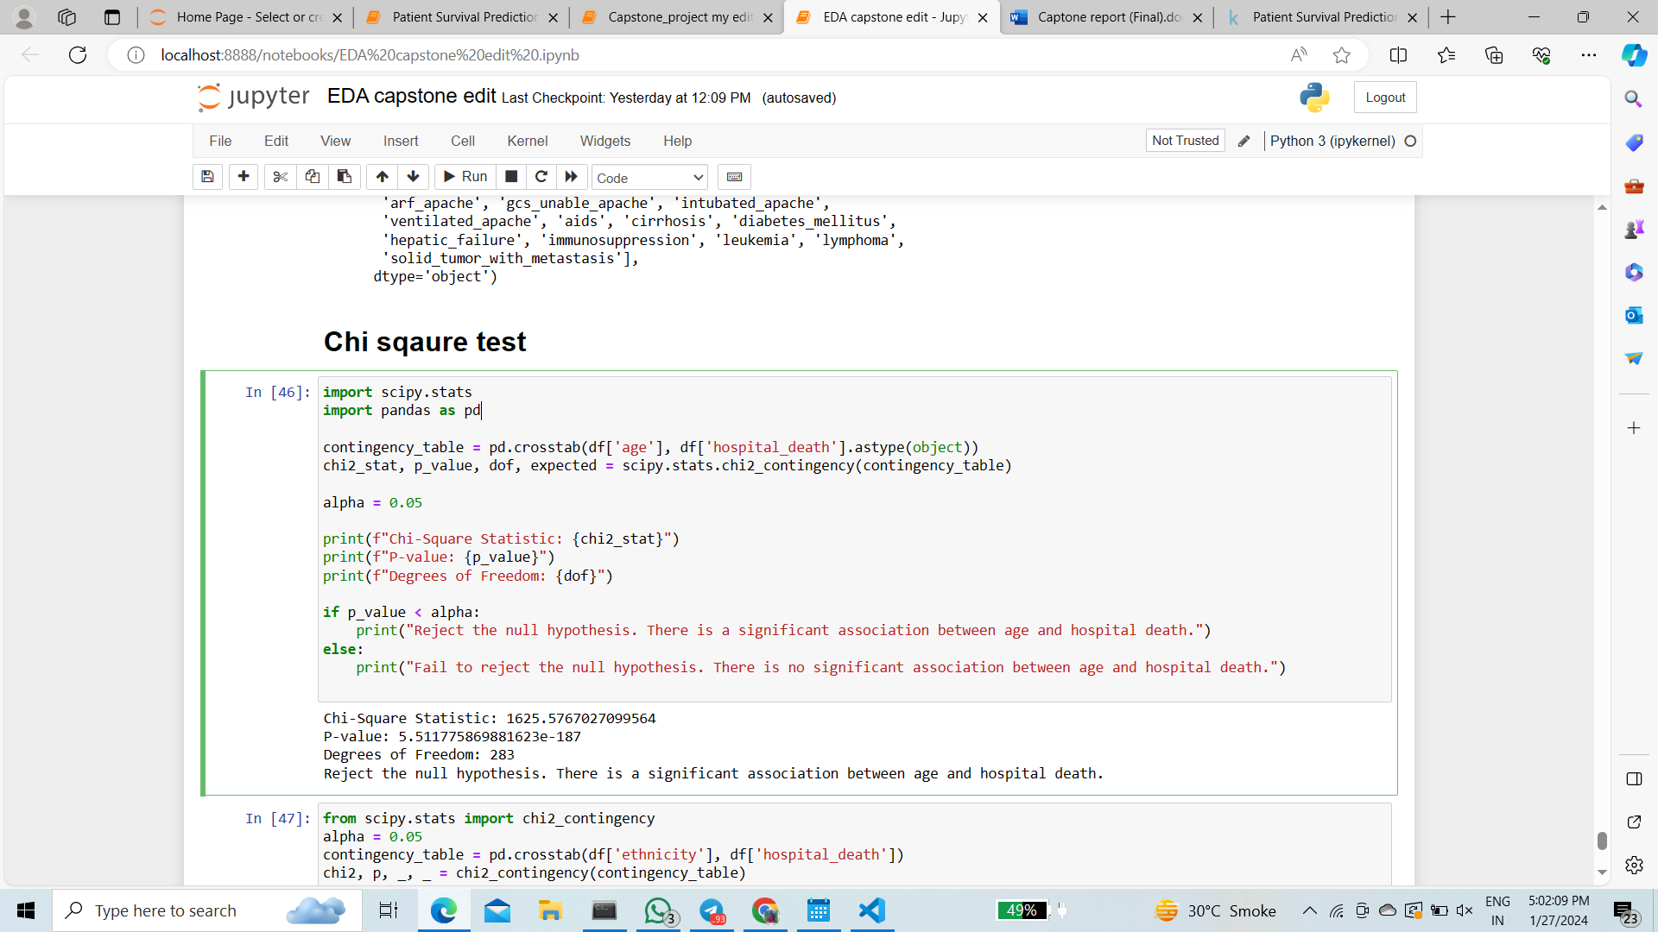

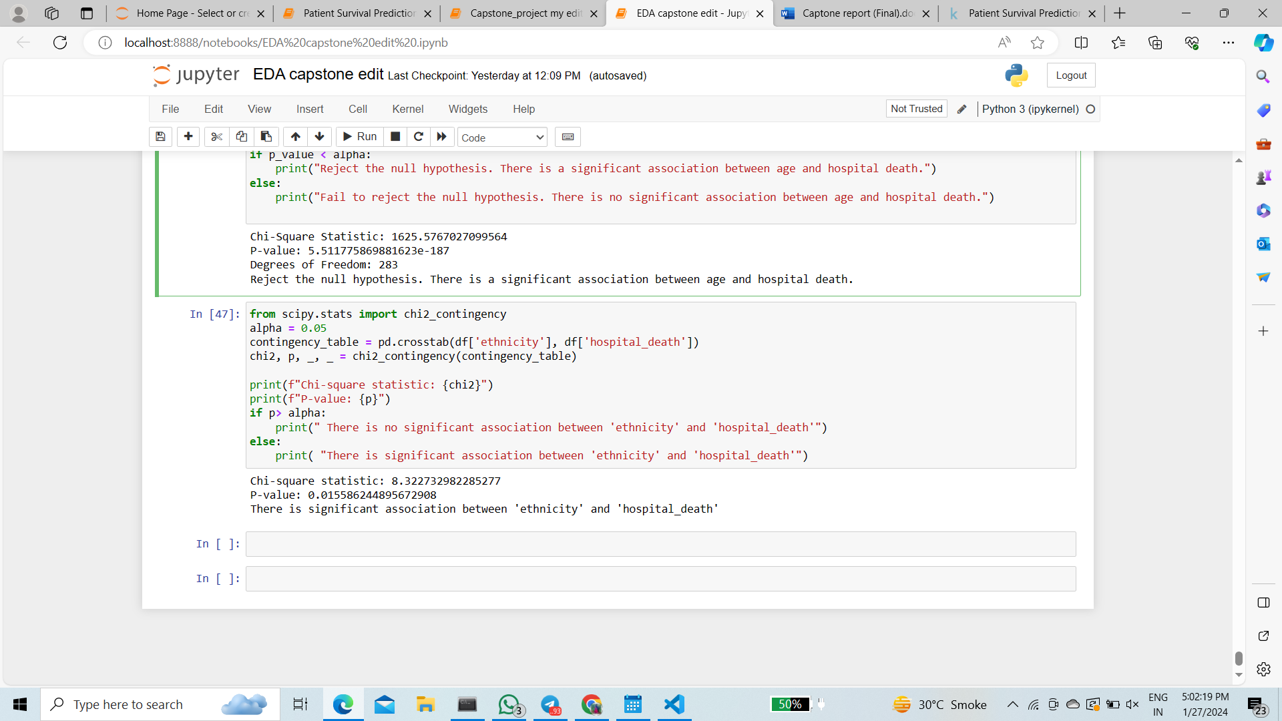

1. We perform stats test between age, ethnicity with target columns which is hospital death and found that age have significant association while ethnicity did not have significant association with the target variable.

**VIF**

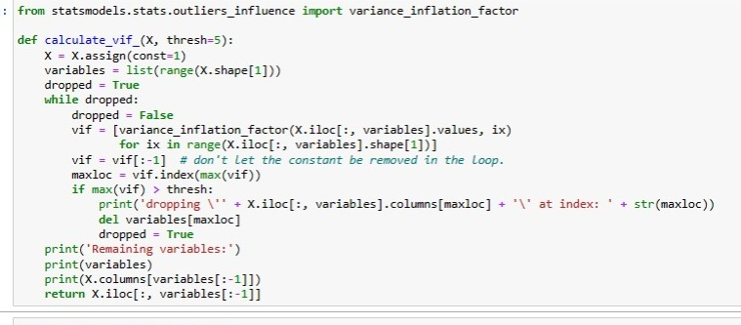

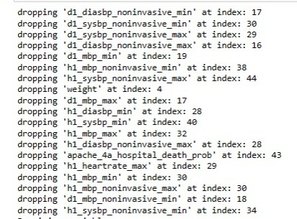

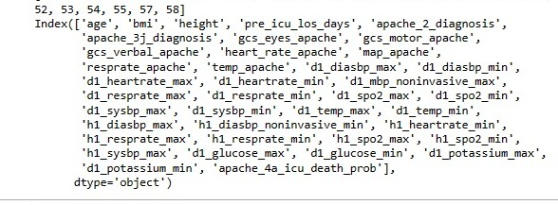

1. While performing Vif with threshold as 5. Dropped 20 columns which are less significant for model building.

**SCALING**

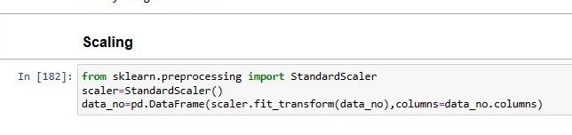

**MODEL BUILDING**

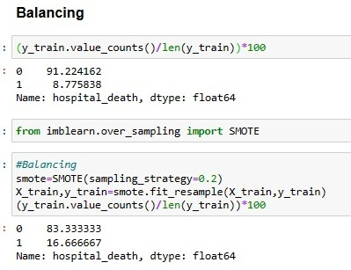

1. We have unbalanced data in the ratio 91: 8
2. We balanced the data using smote technique. In the ratio of 80 : 20

**BASE MODEL**

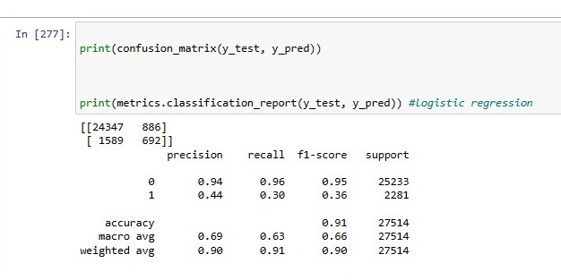

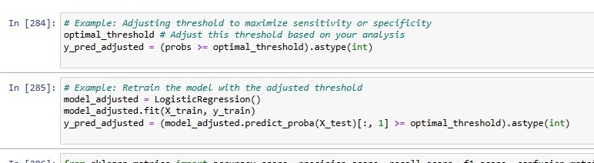

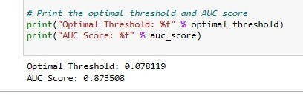

**ROC- AUC CURVE**

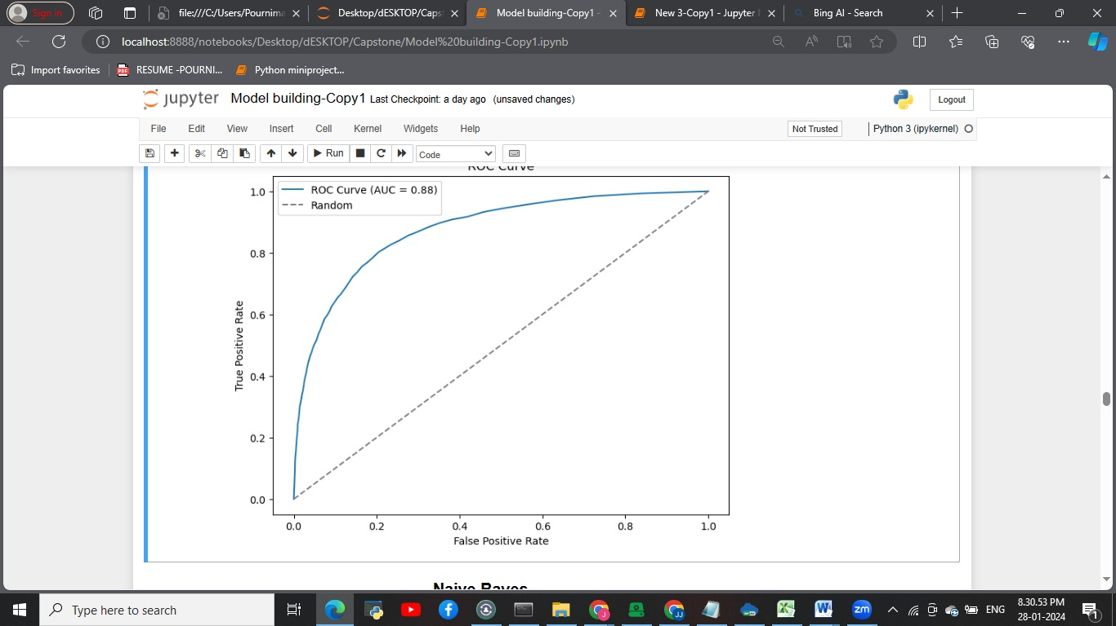

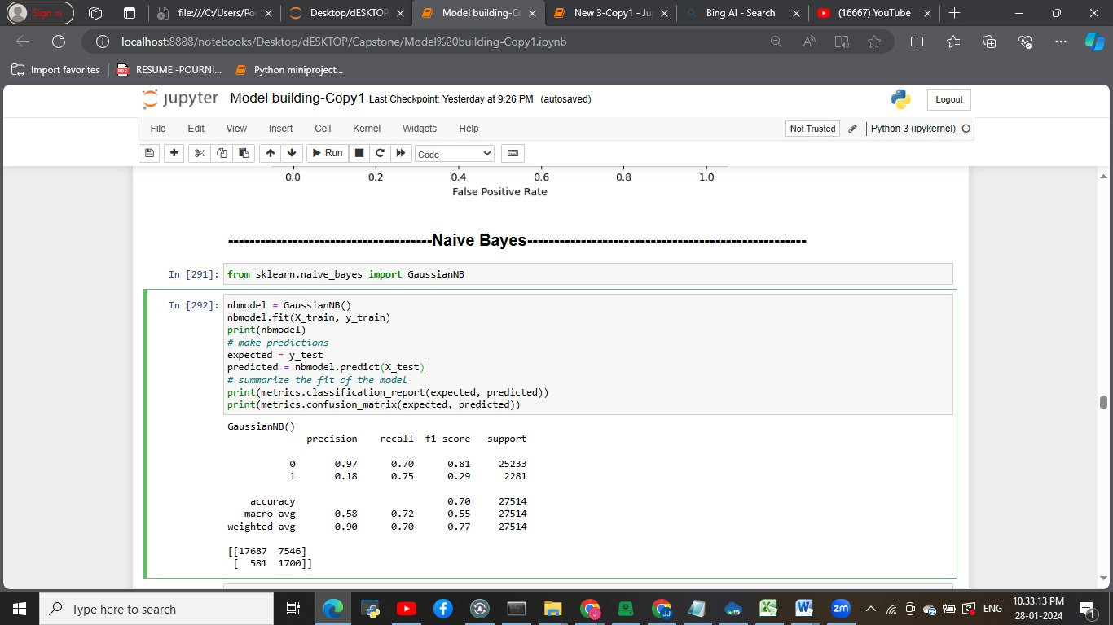

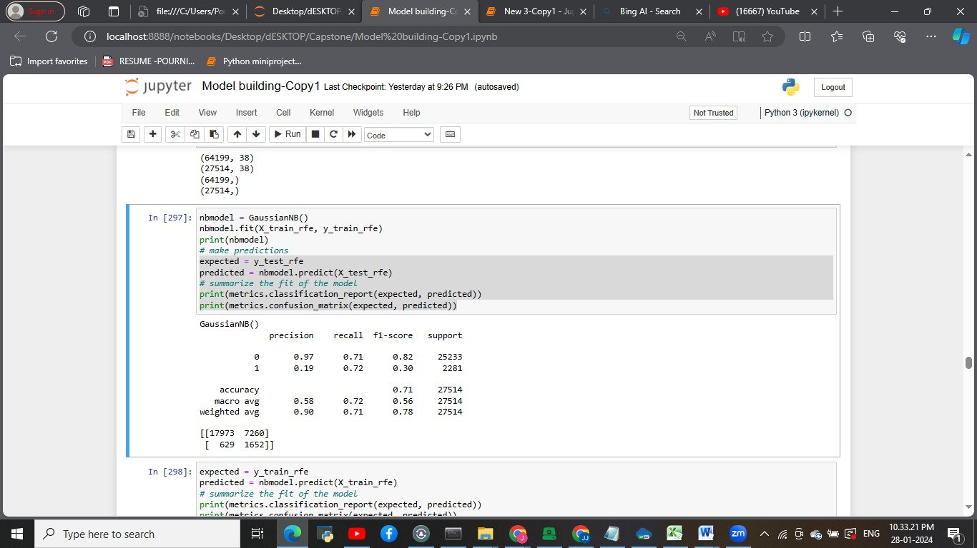

**Bagging Classifier with Decision tree as base model**

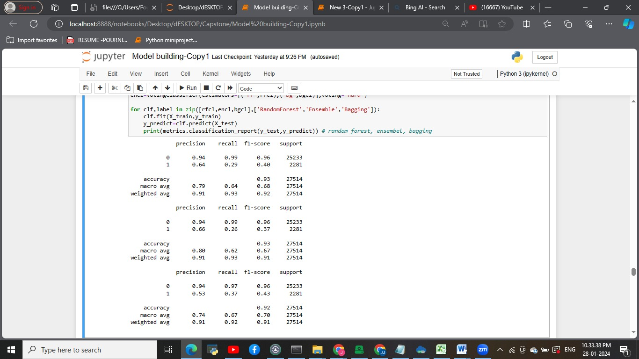

**K- Nearest Neighbour**

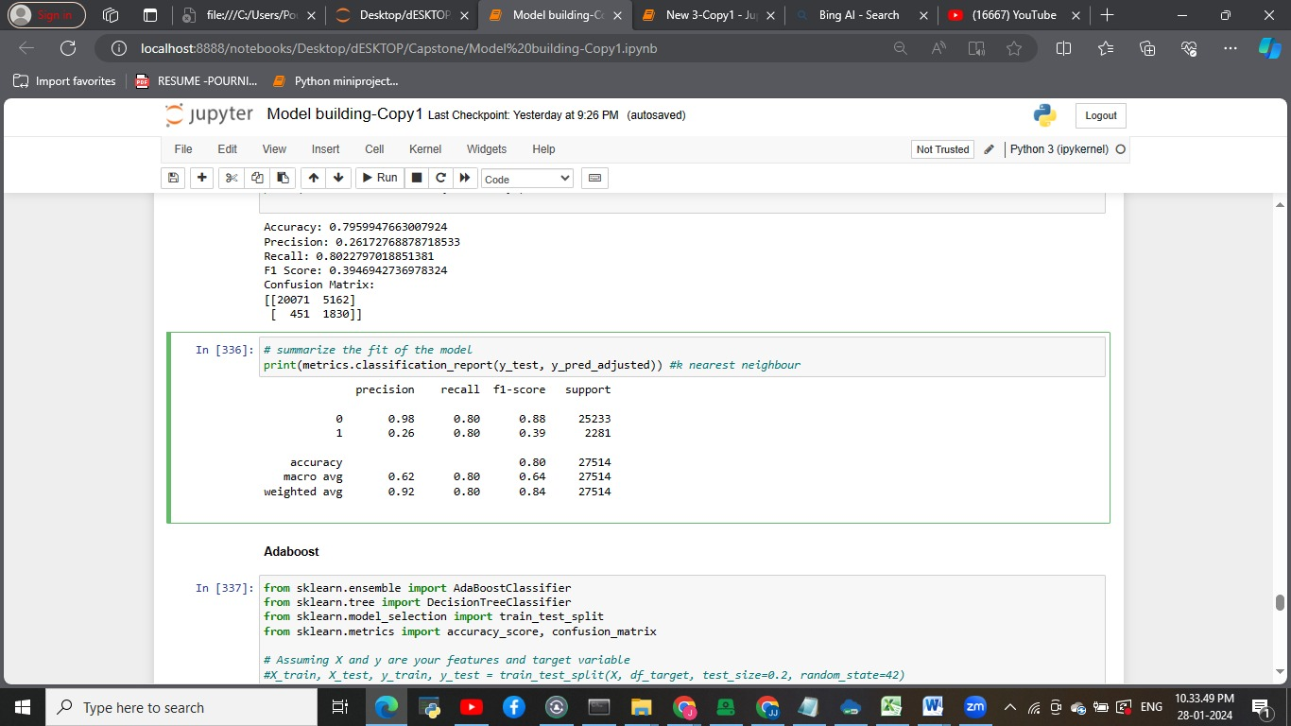

* These are the few models . which we have tried . which did not satisfied the specific bussiness problems
* The recall is not good which is improved in the final model

**FINAL MODEL**

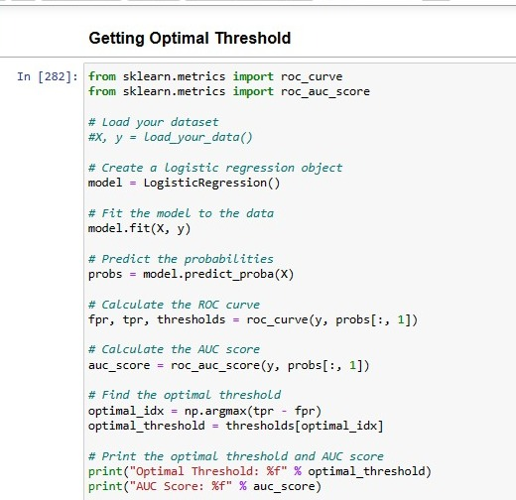

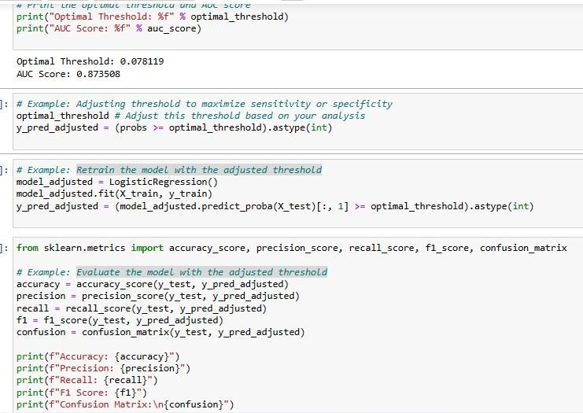

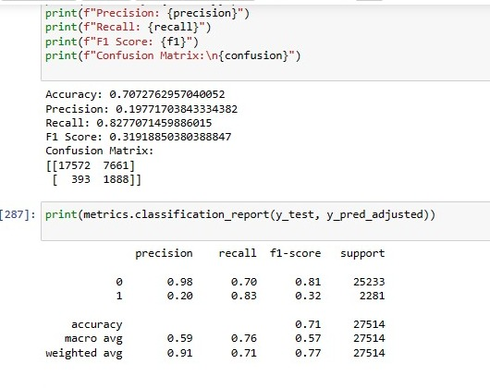

We tried many models such as logistic regression, naive base model, Ada boosting, bagging, random forest classifier. And selected logistic regression with adjusted threshold.

Create a logistic regression object

* Fit the model to the data
* Predict the probabilities
* Calculate the ROC curve
* Calculate the AUC score
* Find the optimal threshold
* Adjusting threshold to maximize sensitivity or specificity
* Retrain the model with the adjusted threshold
* Evaluate the model with the adjusted threshold

**\*\*\*\*\*\*\*\*\*\*\*\*\*\*\*\*\*Model evaluation\*\*\*\*\*\*\*\*\*\*\*\*\*\*\*\*\*\*\*\***

* Precision (Positive Predictive Value): 0.20
* Of all instances predicted as critical, only 20% are true critical cases.
* Recall (Sensitivity or True Positive Rate): 0.83
* The model is able to capture 83% of actual critical cases.
* F1-Score: 0.32
* The harmonic mean of precision and recall is relatively low at 0.32.
* Accuracy: 0.71
* The overall accuracy of the model is 71%.

**\*\*\*\*\*\*\*\*\*\*\*\*\*\*\*\*\*\*\*Interpretation\*\*\*\*\*\*\*\*\*\*\*\*\*\*\*\*\*\*\***

**Precision (0.20):**

A low precision suggests that among the instances predicted as critical, a large proportion are false positives. In other words, there are many instances predicted as critical that are not truly critical.

**Recall (0.83):**

A high recall indicates that the model is effective at capturing true critical cases. However, this comes at the cost of a lower precision.

**F1-Score (0.32):**

The F1-score is a balance between precision and recall. A lower F1-score suggests that achieving a balance between precision and recall is challenging with the current threshold.

**Accuracy (0.71):**

Accuracy provides an overall measure of correct predictions but may not be the most informative metric, especially in imbalanced datasets

**\*\*\*\*\*\*\*\*\*\*\*\*WHY WE SELECTED THIS MODEL\*\*\*\*\*\*\*\*\***

1. Priority on Identifying Critical Cases:

- The primary goal in identifying critical patients is to ensure that the model captures as many true critical cases as possible. Missing critical cases (false negatives) can have severe consequences, potentially leading to delayed or lack of timely intervention.

2. Recall Emphasizes Minimizing False Negatives:

- Recall (sensitivity or true positive rate) specifically measures the ability of the model to identify all relevant instances of the positive class. In the context of critical patients, high recall means minimizing the chances of missing a patient who requires urgent attention.

3. Consequences of False Negatives:

- In healthcare scenarios, the consequences of missing a critical patient can be significant, potentially affecting patient outcomes and safety. Therefore, the emphasis is often on reducing false negatives, even if it results in a higher number of false positives.

4. Trade-off with Precision:

- While precision (positive predictive value) is still important, it may be more acceptable to have a lower precision if it means achieving a higher recall. The cost of false positives (non-critical cases predicted as critical) might be less critical than the cost of missing a true critical case.

5. Timely Intervention and Patient Safety:

- Timely intervention for critical patients is a key consideration. High recall ensures that the model is effective at identifying most, if not all, cases that require urgent medical attention, contributing to patient safety.

**TO DO LIST**

1. Regularization Techniques can be done to improve precision values
2. **Continuous Model Improvement:**

* Implement a continuous improvement strategy for the model by regularly updating it based on feedback, new data, and evolving medical knowledge. This ensures that the model stays relevant and effective in identifying critical patients across different scenarios.

1. **Feedback Loop with Healthcare Professionals:**

- Establish a robust feedback loop with healthcare professionals to gather insights into the model's performance. Encourage open communication to understand cases where the model may have made incorrect predictions and use this feedback to refine the model further.

**Limitation**

* In distribution plot the depression is seen which shows normal range (for example heart rate) and we got ICU patient data whose which cannot be in normal range
* There were three columns which had negative values
* Categorical columns show high number of variability and less repeated values so that we perform Binning of the columns
* There was highly skewed for some of the columns.
* Low precision suggests there are many instances predicted as critical that are not truly critical.

**\*\*\*\*\*\*\*\*\*\*\*\*\*\*\*\*Business insights\*\*\*\*\*\*\*\*\*\*\*\*\*\*\*\*\*\*\*\*\***

**1. Patient-Centric Approach:**

- Prioritize a patient-centric approach that focuses on individualized care. Acknowledge the uniqueness of each patient's medical data and the variability in parameters. Emphasize the importance of personalized risk assessment to cater to diverse patient profiles.

**2. Dynamic Model Thresholds:**

- Recognize that medical data can vary significantly, and different patient populations may exhibit diverse patterns. Allow for dynamic adjustment of the model's decision threshold based on specific patient groups or clinical contexts. This flexibility helps in balancing sensitivity and specificity as needed.

**3. Multidimensional Risk Assessment:**

- Develop a multidimensional risk assessment approach that considers a broad range of parameters and their interactions. Beyond traditional vital signs, incorporate relevant patient history, comorbidities, and laboratory results to provide a comprehensive evaluation of a patient's condition.

**4. Resource Optimization and Alerts:**

- Leverage the model's predictions to optimize resource allocation by providing alerts or recommendations for additional tests and resources when a patient is flagged as potentially critical. This ensures timely interventions and minimizes the risk of overlooking critical cases.

**5. Integration with Electronic Health Records (EHR):**

- Integrate the model seamlessly with electronic health records to facilitate a holistic view of a patient's medical history. This integration enhances the model's ability to make informed predictions by considering longitudinal data and historical trends.

**6. Ethical Considerations and Patient Privacy:**

- Prioritize ethical considerations and patient privacy in the deployment of the model. Ensure that the model adheres to relevant healthcare regulations and standards. Transparency in how the model operates and handles patient data is essential for building trust with both healthcare professionals and patients.

**7. Clinical Validation and Real-World Testing:**

- Conduct rigorous clinical validation and real-world testing to assess the model's performance in diverse healthcare settings. Collaborate with medical professionals to validate the model's effectiveness in different hospitals, clinics, or healthcare systems.

**8. Education and Training for Healthcare Providers:**

- Provide comprehensive education and training to healthcare providers on the model's capabilities, limitations, and interpretability. Empower them to use the model as a supportive tool in their decision-making processes.

**Closing statement**

To improve the model – we can have more balanced data with better sampling techniques.so to improve the precision of the model.

**REFRENCE USED**

**https://www.kaggle.com/datasets/mitishaagarwal/patient**

**---------------------------------------------------------------------------------------------------------------------------------------------**

**---------------------------------------------------------------------------------------------------------------------------------------------**